LEETCODE ARRAY SOLUTIONS

1. FIND THE DUPLICATE NUMBER

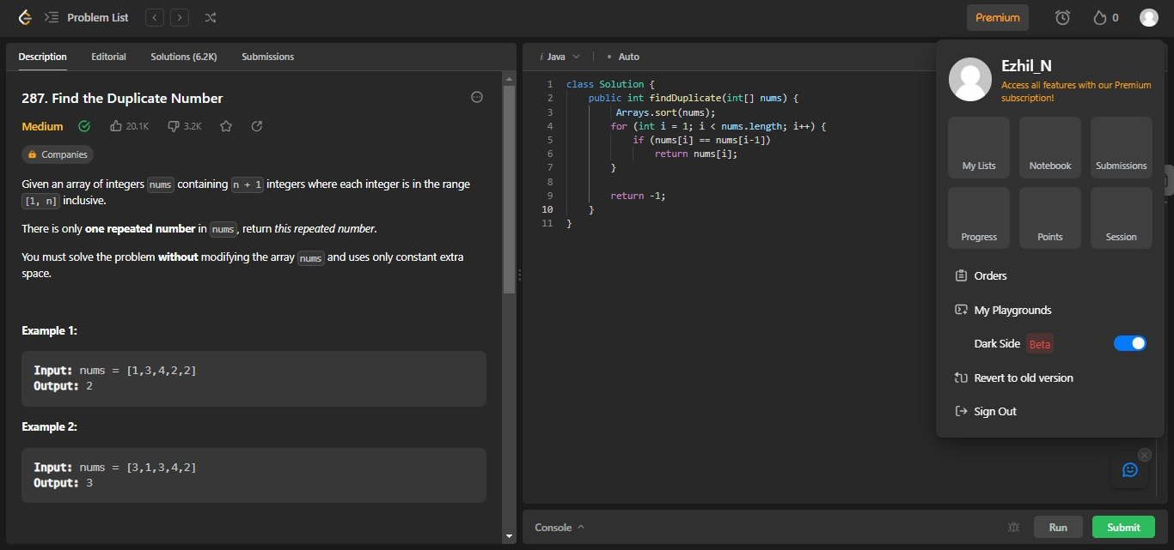

1. NUMBER OF GOOD PARIS

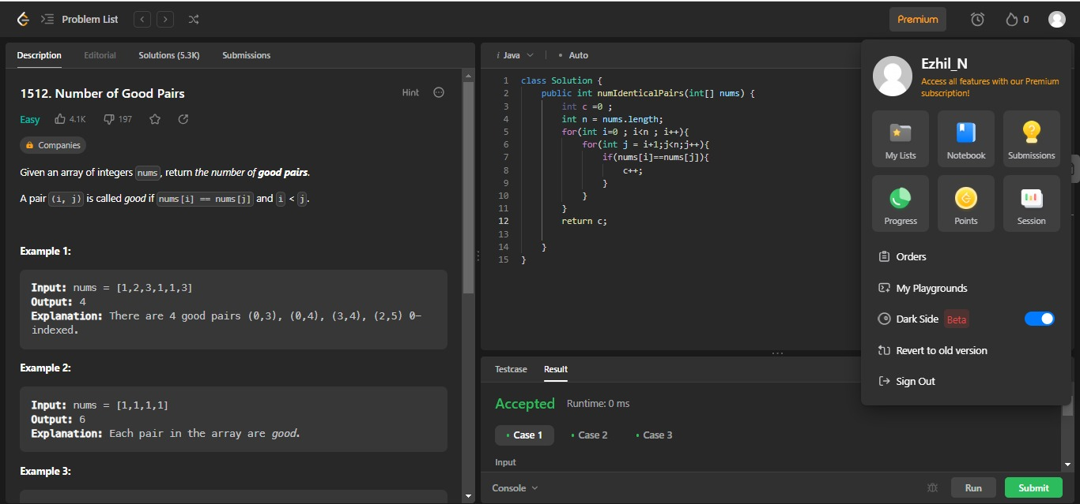

1. FIND GREATEST COMMON DIVISOR OF ARRAY

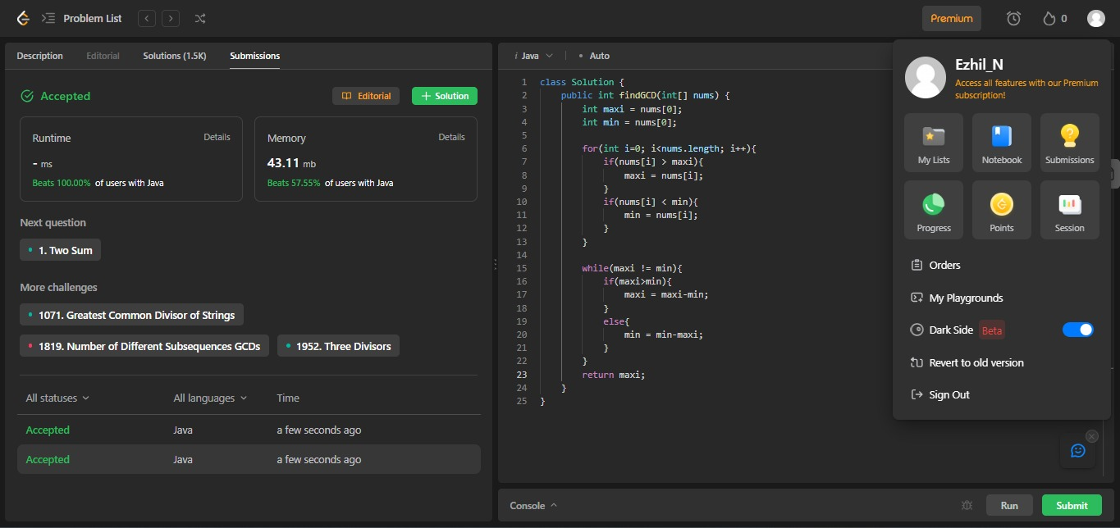

1. UNIQUE NUMBER OF OCCURENCES

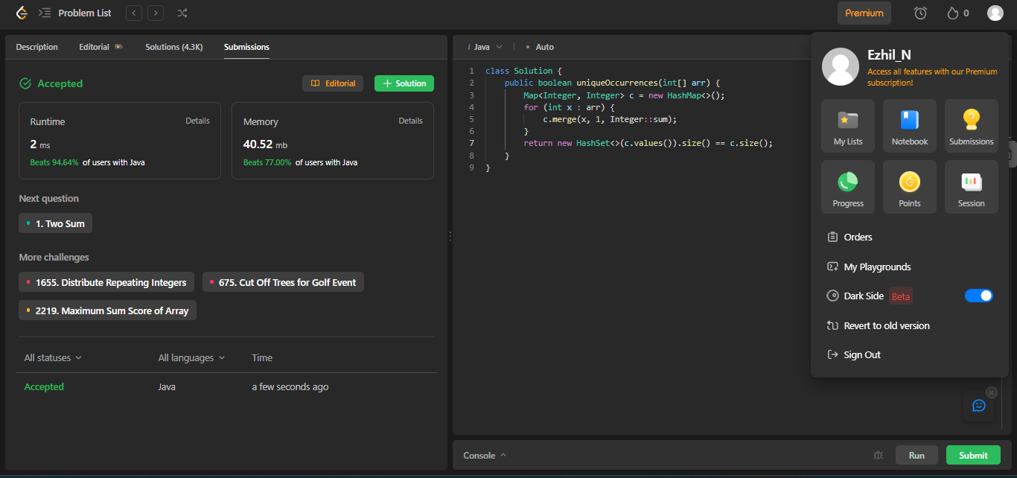

1. FIND ALL DUPLICATES IN AN ARRAY

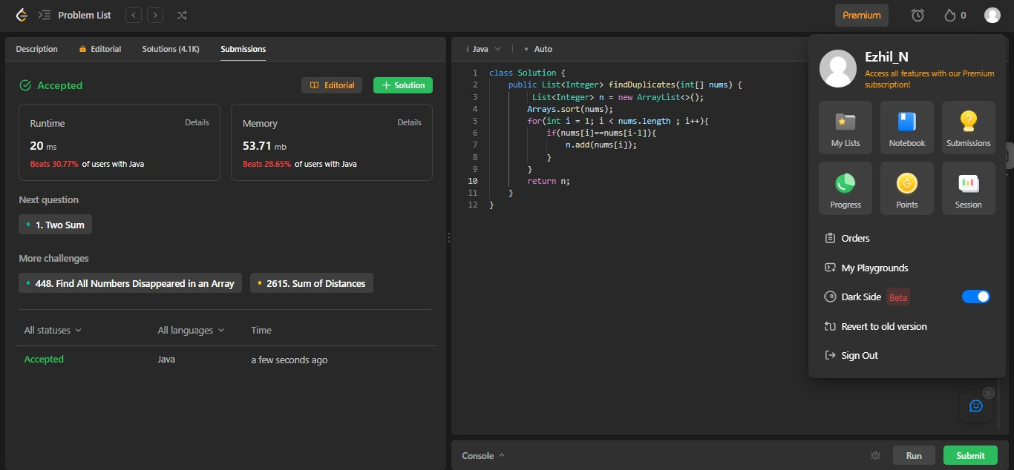

1. MAXIMUM POINTS YOU CAN OBATAIN FROM CARDS

